Your Name |  | Lauren Mazzoli
Step / Points |  | Put your answers for each question below in this column. Note that the cells below set to double space. Please don’t change that!
1.1 | 3 | Dr. E.F. Codd is the father of relational database management systems. He invented this new model in 1970 along with his research team from IBM. The concept of relational database management, improved upon stand-alone individual database files for many reasons. Linking tables together referentially through the use of primary, composite and foreign keys, made it much easier to manage data and improve integrity, reducing duplication, broken references, and data discrepancies. It was also much easier for the IT professionals to use this type of logical and intuitive model because it was no longer necessary to learn a myriad of highly technical systems in order to maintain and gain access to the data. It also made for more efficient retrieval of information which directly correlates to faster processing.  E.F. Codd’s RDBMS theory revolutionized database management and has become the industry standard that serves as the foundation upon which the fast and efficient applications that use SQL to retrieve data are developed in all platforms from mainframes to mobile, and everything in between.
1.2 | 3 | Codd’s new concept in database management was seized by a man named Larry Ellison, who ran with it. Within a decade, Ellison and his company had released the first RDBMS; that first relational database product was named Oracle and SQL was the tool developed to retrieve information from it. Ellison’s company would later be renamed Oracle Corporation and over 30 years later, they remain the industry leader in RDBMS technology and continue to innovate and provide solutions to integrate hardware and software applications to solve business needs. Other companies followed Ellison’s lead, including IBM, and within a few years of Oracle’s release, IBM had their own product on the market which evolved into DB2, which remains a major player in the market that is well- suited for the large legacy IBM platform. Likewise, Microsoft’s version, SQL Server, was developed for Windows servers.  MySQL was released in 1995 by MySQL AB, for their internal company use but it did not become popular until 5 years later when they began allowing others to contribute to its growth and development (open-source database). This decision led to MySQL becoming very popular. It runs on all the commonly used operating systems and is primarily used for web applications. It was purchased by Sun Microsystems in 2008 and is now owned by Oracle Corporation, who acquired Sun two years later.
1.3 | 3 | A join is an SQL method that returns data from two or more tables into one single intermediate table of results called a results set. This is a powerful concept that increases the efficiency and speed of applications because the set of results required can be specified prior to retrieving the data. An “inner join” uses keys that have been pre-defined on each table. The keys are related in the SQL JOIN statement and only the data requested in the columns for those rows that have matching key values is returned. This is the most common type of join.  Another type of join is called an “outer join”. Outer joins do not have a key restraint. This type of join is used to return all rows in the results set even when the related keys do not match. For example, all customer names and addresses should be returned in the results set even when there are no current orders for that customer.
2.1 | 6 | There is a one-to-many relationship between the terms table and the vendors table in the sample AP database. There is one term to many vendors. The terms table holds payment terms data and there is one row for each payment term. A payment term description could be something like “Net 30” or “Due Upon Receipt”. The vendors table contains a row for each vendor that the company purchases items from. The primary key in the vendors table is vendor_id and this uniquiely identifies one instance of a vendor. The vendor table contains an attribute (or column) called default_terms_id of data type INT. This is a foreign key to the primary key of terms_id in the terms table. A vendor’s default_terms_id is the value that will be used when payment terms are not specified for an invoice for this vendor. A payment term, such as “Net 30” could apply to many different vendors. This is an example of a one-to- many relationship.  In order to successfully join these two tables using an inner join clause on the SELECT statement, the primary key of the terms table must be the same data type as that of the foreign key default_terms_id in the vendor table. The default_terms_id must also exist in the terms table. If the payment term does not exist in the terms table, and it is a non-null attribute on the vendors table, this is a referential integrity issue and the terms table or the vendors table has somehow become corrupt. To ensure referential integrity exists, the value of the default_payment_term cannot be set to anything that does not already exists in the terms table. Likewise, the instance of the matching terms_id cannot be deleted from the terms table unless there are no instances of the default_terms_ID in the vendors table.
2.2 | 5 | SELECT vendor_name  FROM vendors  WHERE vendor_state = “OH”  ORDER BY vendor_name
3.1 | 2 | 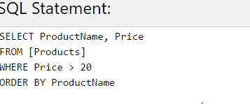  Result:  Number of Records: 37
  ProductName | Price
  Alice Mutton | 39
  Camembert Pierrot | 34
  Carnarvon Tigers | 62.5
  Chef Anton's Cajun Seasoning | 22
  Chef Anton's Gumbo Mix | 21.35
  Côte de Blaye | 263.5
  Fløtemysost | 21.5
  Gnocchi di nonna Alice | 38
  Grandma's Boysenberry Spread | 25
  Gravad lax | 26
  Gudbrandsdalsost | 36
  Gumbär Gummibärchen | 31.23
  Gustaf's Knäckebröd | 21
  Ikura | 31
  Ipoh Coffee | 46
  Louisiana Fiery Hot Pepper Sauce | 21.05
  Manjimup Dried Apples | 53
  Mascarpone Fabioli | 32
  Mishi Kobe Niku | 97
  Mozzarella di Giovanni | 34.8
  Nord-Ost Matjeshering | 25.89
  Northwoods Cranberry Sauce | 40
  Perth Pasties | 32.8
  Pâté chinois | 24
  Queso Cabrales | 21
  Queso Manchego La Pastora | 38
  Raclette Courdavault | 55
  Rössle Sauerkraut | 45.6
  Schoggi Schokolade | 43.9
  Sir Rodney's Marmalade | 81
  Sirop d'érable | 28.5
  Tarte au sucre | 49.3
  Thüringer Rostbratwurst | 123.79
  Tofu | 23.25
  Uncle Bob's Organic Dried Pears | 30
  Vegie-spread | 43.9
  Wimmers gute Semmelknödel | 33.25
3.2 | 3 | 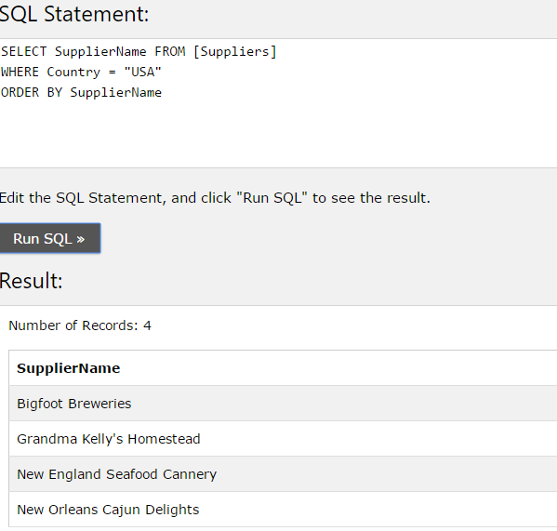
 | 25 | Total

